Specific Architecture Summary

Group 20

Table of Contents
1. Introduction 5
1.1 Purpose of this Document 5
1.2 Document Scope 5
1.3 Terminology 5
1.3.1 Acronyms 5
1.4 Related Documents 6
2. Architecture Overview 7
2.1 Identification 7
2.2 Goals and Objectives 7
2.2.1 Compatibility and Interoperability 7
2.2.2 Extensibility 7
2.2.3 Portability and Platform Independence 7
2.3 The Architectural Model 8
2.3.1 Architectural Concepts and Representations 8
2.4 Technology Stack Diagram and Discussion 9
3. Architectural Specification – User Management and Authentication 11
3.1 Introduction 11
3.2 Overview 11
3.3 Design Methodology 11
3.3.1 MVC implementation 12
3.3.2 Overall CGAS Integration 12
3.3.3 Dependency Matrix 13
3.3.4 UML Diagrams and Discussion 14
3.3.5 Functional Services 15
3.4 Theory of Operations 16
3.5 Security and Ethics 17
4. Architectural Specification – Class & Project List Management 17
4.1 Introduction 17
4.2 Overview 17
4.3 Design Methodology 18
4.3.1 MVC implementation 18
4.3.2 Overall CGAS Integration 19
4.3.3 Dependency Matrix 19
4.3.4 UML Diagrams and Discussion 20
4.3.5 Functional Services 21
4.4 Theory of Operations 22
4.5 Security and Ethics 23
5. Architectural Specification – Group Allocation System 24
5.1 Introduction 24
5.2 Overview 24
5.3 Design Methodology 24
5.3.1 MVC implementation 24
5.3.2 Overall CGAS Integration 25
5.3.3 Dependency Matrix 25
5.3.4 UML Diagrams and Discussion 26
5.3.5 Functional Services 27
5.4 Theory of Operations 27
5.5 Security and Ethics 28
6. Architectural Specification - Student Information System 28
6.1 Introduction 28
6.2 Overview 28
6.3 Design Methodology - Talk about how your techstack interacts with the component 29
6.3.1 MVC implementation 29
6.3.2 Overall CGAS Integration 30
6.3.3 Dependency Matrix 31
6.3.4 Interface Discussion 32
6.3.5 Functional Services 33
6.4 Theory of Operations 33
6.4.1 Profile Flow (Student) 34
6.4.2 Dashboard Flow (Student) 34
6.4.3 Profile Flow (Administrator) 35
6.5 Security and Ethics 35
7. Architectural Specification - Application Round Management 35
7.1 Introduction 35
7.2 Overview 36
7.3 Design Methodology 36
7.3.1 MVC implementation 36
7.3.2 Overall CGAS Integration 37
7.3.3 Dependency Matrix 37
7.3.4 Interface Discussion 38
7.3.5 Functional Services 39
7.4 Theory of Operations 39
7.4.1 Application Round Creation 39
7.4.2 Application Submission 39
7.4.3 Application Status Retrieval 40
7.4.4 Round Closure and Review 40
7.4.5 Integration with Group Allocation 40
7.5 Security and Ethics 40
8. Architectural Specification – Notification System 40
8.1 Introduction 40
8.2 Overview 41
8.3 Design Methodology 41
8.3.1 MVC implementation 41
8.3.2 Overall CGAS Integration 42
8.3.3 Dependency Matrix 43
8.3.4 Interface Discussion 44
8.3.5 Functional Services 45
8.4 Theory of Operations 45
8.4.1 Preference Editing Flow 45
8.4.2 Notification Viewing Flow 46
8.4.3 Notification Dispatch Flow 46
8.5 Security and Ethics 47
9. Architectural Specification – Reporting and Export Management 47
9.1 Introduction 47
9.2 Overview 47
9.3 Design Methodology 48
9.3.1 MVC implementation 48
9.3.3 Dependency Matrix 48
9.3.4 UML Diagrams and Discussion 49
9.3.5 Functional Services 50
9.4 Theory of Operations 50
9.5 Security and Ethics 51
10. Architectural Specification - Performance Monitoring, Error Handling and Debugging 51
10.1 Performance Monitoring 51
10.2 Debugging 51
10.3 Error Logging 52

1. Introduction
The purpose of this document is to provide detailed architecture specification information for the Capstone Group Allocation System (CGAS), outlining its core non-functional requirements. It defines the systems’s architectural design, including key components, interactions and deployment considerations required to support the application. This document also establishes the constraints, performance expectations and security considerations that guide the system’s implementation. It serves as a reference for developers, architects and stakeholders to ensure that the system is designed in a scalable, maintainable and secure manner.

1.1 Purpose of this Document
This document provides a comprehensive architectural overview of the system, using multiple architectural views to represent different aspects of the system. It captures and communicates the key architectural decisions made throughout the development of the system. The document also outlines the structure, components and interactions that define the systems’ behaviour. It serves as a reference for stakeholders to understand, evaluate and guide the system’s implementation and evolution.

1.2 Document Scope
This Software Architecture Document provides an architectural overview of the Capstone Group Allocation System (CGAS). The system is being developed by Group 20 as a part of the Capstone Computing Project 1 (ISAD3000, Semester 1 2026) at Curtin University to support capstone group registration and allocation processes. It outlines the system’s structure, components and interactions, along with key architectural decisions and constraints. The document has been prepared by the project team to guide development and stakeholder understanding of the system architecture.

1.3 Terminology

1.3.1 Acronyms

Acronym | Definition
CGAS | Curtin Group Allocation System
MVC | Model, View, Controller; A pattern that is meant to outline specific roles for code to follow to prevent scope creep and poor formatting
TIS | Technology Investigation Summary
SRS | Software Requirement Specification
PDF | Portable Document Format
CV | Curriculum Vitae
APP | Australian Privacy Principle
RBAC | Role-based Access Controls
UC | Unit Coordinator
HCI | Human Computer Interface
UMA | User Management and Authentication; An internal system that supports platform security

1.4 Related Documents
The following Documents are referenced by the Software Architecture Specification

Title | Revision Version
Technology Investigation Summary G20 | 1.0
Software Requirements Specification G20 | 2.0

2. Architecture Overview

2.1 Identification
This document describes the software architecture for the Curtin Group Allocation System, or CGAS. This document will go into detail about the specifications for each component’s software architecture, as well as the theoretical operational flow of said components,
This document will be utilized by ISAD3000 Group 20 for development of the CGAS within 2026, with the developmental context of the web-application being supplemented by the previously provided TIS and SRS documentation.

2.2 Goals and Objectives

2.2.1 Compatibility and Interoperability
The CGAS architecture shall be designed in such a manner as to allow it to operate on the three most common operating systems (MacOS, LinuxOS and Windows). In order to ensure this, the architecture will be developed in accordance with industry standard interfaces and following coding best practices. This will also ensure that the web application remains interoperable with third party Web 3 technologies.

2.2.2 Extensibility
The components of the CGAS architecture will be developed with a level of extensibility that is at least satisfactory for a 3 year life cycle following the current projected rate of software industry evolution. By ensuring that the application is developed using modern, up to date libraries and frameworks for application design on the browsers listed within the SRS, the architecture should remain extensible.

2.2.3 Portability and Platform Independence
The CGAS shall be designed in a manner that emphasises the portability of the application’s code. In order to ensure this, the application’s architecture will employ the use of the MVC pattern for its classes and sub-components. Adherence to this pattern will limit the level of unnecessary coupling within the code, as well as ensure the code of each component remains both modular and portable. Due to the application’s web-based nature, the application should not be optimized nor incapable of running on any single platform.

2.3 The Architectural Model

2.3.1 Architectural Concepts and Representations
The architecture of the CGAS system is based on a layered and component-based design approach. The layered and component-based design methodology provides for separation of the system into distinct layers where each layer performs only those functionalities that are specific to it. The layered design approach enables improved modularity, scalability and maintainability in comparison with monolithic systems.
The primary architectural concept used in designing the CGAS system is a multi-tier architecture which consists of three main layers: presentation layer (frontend), application layer (backend), and data layer (database). Each tier operates independently but communicate through well-defined interfaces therefore enabling loose coupling between components. The separation between tiers allows changes in one tier to have minimal impact upon other tiers.
In addition, the client server model is implemented throughout the CGAS system. The frontend (client) interacts with the backend (server) using api calls. The backend processes requests from users, applies business logic, and retrieves or stores data in/from the database. This implementation enables efficient handling of user requests, supports scalability for multiple users, and maintains loose coupling between components.
The service-oriented approach is incorporated within the CGAS system by integrating external services such as email hosting. These external services are accessed via their respective APIs. This enables the CGASsystem to extend its functionality without increasing internal complexity.
The block diagram represents the overall architecture of the CGAS system. Each major component (presentation layer/frontend, application layer/backend, data layer/database, etc.) is represented as separate blocks. Sub-components within each block illustrate the internal functionalities associated with each major component. Lines connecting the components indicate different types of interactions (data flow, service calls, deployment relationships).
Visual indicators are utilized to distinguish among different types of connections (development flow, service communication, deployment structure). Visual indicators may include use of arrows and colors. The representation provided by the block diagram provides stakeholders with a clear understanding of how the components of the CGAS system interact and are deployed.
In general, the architectural representation provides a high-level abstraction of the CGAS system. This representation provides stakeholders an understanding of the system's structure, relationship between components and data flows without requiring low-level details concerning implementation.

2.4 Technology Stack Diagram and Discussion
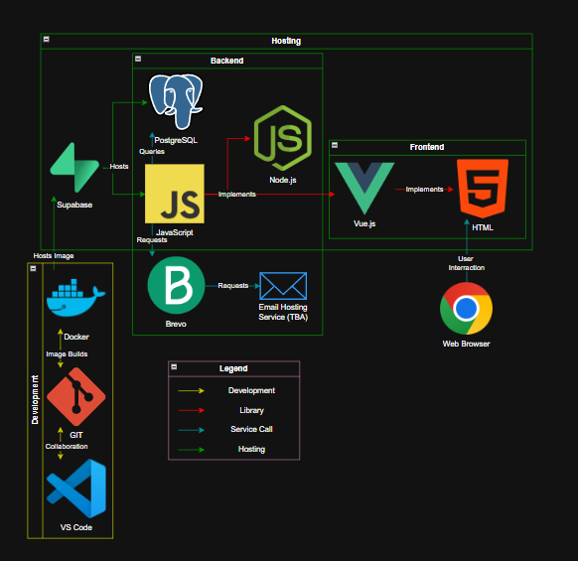
Figure 2.4.1 “CGAS Technology Stack Diagram”

The CGAS System utilizes a contemporary multiple tiered architecture which includes the Frontend, Backend, Database, and External Services in a Hosted Environment.
The Frontend Layer is comprised of Vue.js and HTML Standards. As such, it is responsible for accepting input from the end-user utilizing their Web Browser.
In addition to receiving input from the User, this layer will allow users to submit requests, view information about the status of those requests, and provide a method for users to interact with the Systems Interface.
The Frontend Layer will communicate with the Backend Layer via Application Programming Interfaces (APIs).
The Backend Layer is developed using Node.js and JavaScript. It serves as the main Processing Unit of the System. In this capacity, it is responsible for Business Logic related to how the System functions.
As part of its responsibilities, the Backend Layer will process requests from the Frontend Layer and then use APIs to access data stored in the Database.
The Database Layer is based on PostgreSQL and is provided by Supabase. This Layer is responsible for Storing All Data related to the System's operation. This includes data entered by Users and operational History. In addition to providing Storage Functions, Supabase offers Backend Services such as Authentication and Hosting APIs. These services allow the Backend Layer to efficiently interact with the Database.
As well as being able to Store Data and Interact with the Backend Layer, the System also has the ability to interact with external services. For example, it can utilize Brevo to perform Email-Related functions. This enables the Backend Layer to notify Users or Confirm Requests through a Third Party Email Hosting Service.
All components of the System are Deployed Using Containerization Technologies such as Docker. In addition, the Source Code for the System is Stored in Version Control Repositories using Git. Tools such as Visual Studio Code are utilized to develop new Features and Enhancements for the System.
Hosting Services make sure that Users have access to the System's Functionality via their Web Browser.
Overall, the Architecture of the System was Designed to be Modular, Scalable, and Maintainable. It was designed to separate each layer of the System into clear functional groups: Frontend Layer, Backend Layer, and Data Layer. Separating these Functional Groups will enable Developers to Develop, Test, and Make Enhancements to the System more easily than they would if they were combined into one Functional Group.

3. Architectural Specification – User Management and Authentication

3.1 Introduction
This section outlines the User Management and Authentication component of the system. It describes the core responsibilities of the component, including user registration, authentication and role-based access control. The section also explains how this component integrates with other system components to manage secure access and user interactions. Where appropriate, supporting diagrams have been included to clarify workflows and implementation concepts.

3.2 Overview
The User Management and Authentication component is responsible for managing user identities and controlling access to the CGAS system. It provides functionality for user registration, secure login and session management, ensuring that only authenticated users can access their components of the system. The component also enforces role-based access control (RBAC), allowing different user types, such as; Students, Unit Coordinators and Administrators, to access only the features and data relevant to their role. While it governs authentication and access, the execution of role-specific functionality is handled by other components within the system.

3.3 Design Methodology
The User Management and Authentication components is implemented using the selected technology stack, comprising of a Vue.js frontend, a NestJS backend (Node.js ith TypeScript), Supabase for authentication and hosting services and PostgreSQL for persistent data storage. Each layer of the stack contributed so the secure handling of user identity and access control.
The Vue.js frontend is responsible for capturing user input, such as login credentials and registration details and communicating securely with the backend via API calls. The NestJS backend manages application logic, including request validation, authentication workflows and enforcement of RBAC. Supabase provides integrated authentication services, handling user registration, email verification, session management and token-based authentication. PostgreSQL is used to store user-related metadata, role assignments and access control information, ensuring data integrity through structured schemas and constraints.
Interaction between these technologies ensures that authentication requests are processed securely, user sessions maintained reliably and access permissions are consistently enforced throughout the system.

3.3.1 MVC implementation
The User Management and Authentication component follows a Model-View-Controller (MVC) architectural pattern with responsibilities distributed across each layer to ensure separation of concerns and maintainability.
- Model - This layer is managed through PostgreSQL and Supabase where user accounts, authentication data and role assignments are stored. This layer enforces data integrity and supports secure access through structured schemas and role-based access policies.
- View - This layer is implemented using Vue.js and provides interfaces for user registration, login and account management. It captures user input and communicates with the backend exclusively through defined API endpoints to ensure clear separation from business logic.
- Controller - This layer is handled by NestJS which processes authentic action requests, validates inputs and coordinates with Supabase services for user verification and session management. It acts as the intermediary between the frontend and database layers, enforcing access control and ensuring secure consistent handling of user interactions.
This structure ensures modularity, maintainability and secure separation of concerns across all components.

3.3.2 Overall CGAS Integration
The User Management and Authentication component serves as a foundational service within the CGAS architecture, acting as the key entry point for all user access throughout the system. Its primary role is to authenticate users and enforce RBAC before allowing interaction with other components.
This component interacts with the PostgreSQL database to store and retrieve user credentials, role assignments and authentication related data. It also integrates with Supabase authentication services to manage login, registration, email verification and session handling. All communication between users and the system is routed through this component during authentication, ensuring that access is validated prior to and further interaction.
Unlike feature-specific components, this component is indirectly connected to all other components in the system. It does not directly manage their functionality but provides the access control layer that governs whether users can interact with them. Other components rely on authentication tokens and role information generated by this component to enforce permissions.
Additionally, this component supports secure communication across the application by ensuring all authentication processes occur over HTTPS and that session data is validated on each request. This positioning makes it a critical cross-cutting component that underpins the security and access structure of the entire CGAS system.

3.3.3 Dependency Matrix

Sub-Component | Dependency
Login UI | Authentication Request Port, Authentication API
Registration UI | Registration Request Port, Registration API
Email Verification UI | Verification Request Port, Verification API
Authentication Controller | Authentication Service
Registration Controller | Registration Service
Verification Controller | Verification Service
Authentication Service | Session Service, User Service
Registration Service | User Service, Token Generator, Email Service, User Data (Database) Port
Verification Service | Token Generator, User Data (Database) Port
Session Service | Session Gateway Port, Web Return Port, User Data (Database) Port
User Service | User Data (Database) Port, Database Access Port
Email Service | Email Gateway Port, Email API
Authentication Schema | Tables - VerificationTokens, Sessions, Roles and Users
Email API | Email Provider (External)

3.3.4 UML Diagrams and Discussion
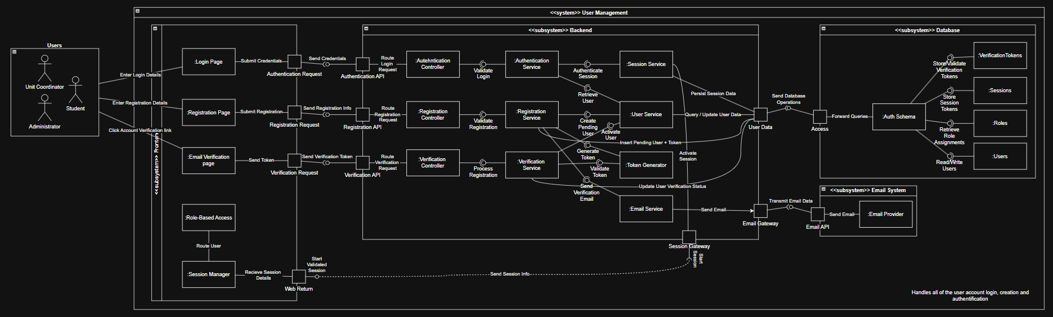
Figure 3.3.4.1 “User Management UML Diagram”
There are several key interfaces defined within the User Management and Authentication (UMA) component, distributed across frontend, backend and database layers. These interfaces facilitate secure communication between sub-components while maintaining separation of concerns and enforcing controlled access to authentication functionality.
The Authentication Request Port is used by the Login UI to transmit user credentials to the Authentication API. This interface supports a request-response interaction where credentials are sent securely and authentication results are returned as JSON responses.
The Registration Request Port is used by the Registration UI to submit new user details to the Registration API. This interface handles account creation requests and also operates in a request-response manner with validation results and account status returned via JSON to the frontend.
The Verification Request Port is used by the Email Verification UI to submit verification tokens to the Verification API. This interface enables account activation and password change workflows, operating as a request-response interaction, returning verification statuses as JSON.
The Authentication API is provided by the Authentication Controller and is consumed by the Login UI via the Authentication Request Port. It validates credentials, generates authentication tokens and initiates session creation. Data is exchanged as JSON format.
The Registration API is provided by the Registration Controller and is consumed by the Registration UI via the Registration Request Port. It processes user creation requests, interacts with backend services for validation and persistence and triggers email verification workflows.
The Verification API is provided by the Verification Controller and is consumed by the Email Verification UI via the Verification Request Port. It validates verification tokens and updates user account statuses accordingly.
The Session Gateway Port is used internally by the Session Service to manage session creation, validation and termination. It interacts with session storage and ensures secure session lifecycle management. The relationship is request-response, with session data exchanged securely.
The Web Return Port is provided by frontend components (Login UI, Registration UI and Verification UI) to receive responses from backend controllers. This interface delivers authentication results, error messages and status updates in JSON format.
The User Data (Database) Port is provided by the database layer and acts as the primary interface for backend services to access user, role, session and verification data. It supports request-response interactions with structured queries submitted by backend services and results returned from the database.
The Email Gateway Port is used by the Email Service to communicate with the external Email API provider. This interface handles outbound email requests, such as verification emails and operates in two-way interaction, with delivery status and responses returned by the external service.
Wholistically, these interfaces establish a secure, modular communication framework that supports authentication workflows, enforces access control and integrates seamlessly with both internal and system components. Furthermore construction of the foundational layer of the UMA system.

3.3.5 Functional Services
The UMA component provides the following key functional services:
- User Registration - Enables new users to create an account by submitting required details, with account activation enforced through email verification.
- User Authentication (Login / Logout) - Allows users to securely log in and out of the system using validated credentials with session management ensuring persistent and secure access.
- Email Verification - Ensures that users correctly verify ownership of their email address before gaining full access to the system, improving account security and integrity.
- Role-Based Access Control (RBAC) - Assigns and enforces user roles (e.g. Student, Unit Coordinator, Administrator), ensuring users can only access data and functionality relevant to their role.
- User Data Management - Supports the storage and retrieval of user account information including credentials, roles and authentication status.
- Audit and Logging Services - Records authentication related events such as logins, registrations and verification attempts to support monitoring, security and accountability.
In addition, the UMA component allows users with elevated privileges (Administrators) to manage user roles and oversee account activity, supporting system governance and system usage insights.

3.4 Theory of Operations
The User Management and Authentication (UMA) component acts as the primary access control layer for the CGAS, ensuring that all users are authenticated before interacting with the system. All incoming requests from the frontend are routed through backend authentication endpoints where credentials are validated and user sessions are established. It supports registration, email verification, login, session handling and role-based access control (RBAC).
During registration, the Registration UI submits user details through the Registration Request Port of the Registration API. The Registration Controller receives these details and passes them to the Registration Service where methods such as validateRegistrationDetails(), crreateUserAccount() and generateVerficationToken() may be used. The Email Service is called to send a verification email through the EMail Gateway Port and external Email API. This supports the functional requirement for secure user account creation and helps ensure users verify ownership of their email addresses before obtaining system access.
During email verification, the users follow the verification link provided to navigate through the Email Verification UI. The Verification API receives this request and passes it to the Verification Service which may use functions such as validateVerificaitonToken() and activateUserAccount(). The User Data Port is then used to update the user’s verification status in the Authentication Schema.
During login, the Login UI submits credentials securely over HTTPS through the Authentication Request Port to the Authentication API. The Authentication Service validates the credentials, checks whether the account is verified and creates a session using the Session Service. Methods such as authenticateUser(), validatePassword() and createSession() may be implemented. The Web Return port then returns the authentication result, session token and role information to the frontend system.
For session management, each authenticated request carries a session token. The backend validates this token through the Session Service before allowing the request to continue. This supports the non-functional requirement for security and performance by ensuring access controls are consistent and handled through a centralised mechanism.
For role-based access control (RBAC), the User Service retrieves the user’s assigned role from the Authentication Schema via the User Data Port. backend controllers then use this role information to determine whether the user is permitted to access requested features. For example, Students are directed to student functionality, while Unit Coordinators and Administrators are given access to exclusive management functions. This directly supports the functional requirement that users can only access data and features relevant to their role.

3.5 Security and Ethics
The UMA component is responsible for protecting user identity and ensuring secure access to the CGAS. It manages sensitive data such as credentials, access permissions and student emails. This requires compliance with Australia’s Privacy Protection Act (1988) and following of responsible data handling practices.
Security is enforced through mechanisms such as encrypted communications (HTTPS), secure credential handling, hashed session tokens and role-based access control. These measures ensure that users are only able to access data and functionality appropriately assigned to their role, reducing any risk of unauthorised access.
From an ethical perspective, the system prioritises transparency and data minimalisation. Users are informed of how their data will be used through a privacy policy presented during registration, and only essential information is collected. Administrative access is also restricted to prevent unnecessary exposure of user data.
Together, these practices ensure that the system maintains confidentiality, integrity and user trust while meeting legal and ethical obligations.

4. Architectural Specification – Class & Project List Management

4.1 Introduction
The Class and Project List Management component is responsible for managing both student enrolment data and project definitions within CGAS. It enables Unit Coordinators to upload and manage class lists and create or configure project offerings. This component supports downstream processes such as application management and group allocation by providing a reliable source of enrolment data.

4.2 Overview
The Class and project List Management component is designed primarily for Unit Coordinators to manage enrolment and project data within the CGAS. It provides functionality to upload and process class lists (e.g., CSV Uploads), creating and maintaining student records as we all create, update and manage project listings available for application. The component ensures that both student and project data is validated, consistent and accessible to other system components. While it manages the preparation and organisation of this information, it does not handle application submissions or group allocation logics as these are handled elsewhere within the system.

4.3 Design Methodology
The Class and project List Management component is implemented using the established technology stack of Vue.js (Frontend), NestJS (Backend), Supabase services and PostgreSQL for data storage. This component is responsible for handling structured data ingestion (class lists) and project configuration, requiring strong validation, data integrity and controlled access systems.
The Vue.js frontend provides the interfaces for Unit Coordinators to upload class lists and manage project entries. These interfaces communicate with backend APIs via defined ports, ensuring that there is no direct coupling with data storage. The NestJS backend processes incoming requests, performs validation (CSV parsing, schema checks and file validation) and coordinates business logic such as student and project record creation. Supabase supports secure communication and integration while PostgreSQL stores the relevant data (Student, Class and Project) using structured schemas and constraints.
This layered interaction helps ensure that data is validated before persistence, maintaining traceable operations and retaining component modularity and maintenance.

4.3.1 MVC implementation
The Class and Project List Management component follows the MVW architecture, separating data handling, presentation and control logic through the layers.
- Model - This layer is implemented directly in the PostgreSQL database and consists of schemas storing Students, Classes, Projects and their interconnected relationships. This layer enforces data integrity through constraints, keys and relationship enforcement.
- View - This layer is provided by the Vue.js frontend. It includes sub-components such as Class List Upload UI and Project Management UI. These components allow Unit Coordinators to submit CSV files, create projects and view existing data. All communication occurs through defined API endpoints.
- Controller - This layer is handled by the NestJs backend. It is where controllers receive requests from the frontend, incorporate the required action (e.g., Create, Update, Delete) and routes them to the appropriate services. The service performs validation (CSV parsing, schema checks and file validation) before finally interacting with the database through defined data ports.
This structure helps ensure a clean separation of concerns, allowing each layer to operate independently while maintaining a consistent and secure data flow throughout the component.

4.3.2 Overall CGAS Integration
The Class and project List Management component acts as a foundational data provider within the CGAS< supplying structured student enrolment and project information to other system components. It is primarily interacted with by Unit Coordinators who will initiate data uploads with Class Lists and project configuration through the frontend interfaces.
The component interacts directly with the CGAS database (PostgreSQL) to store and maintain student, class and project records. These records are then consumed by other components such as the Application Management and Group Allocation systems which will rely on this data to function correctly. For example, the application rounds depend upon project listings and the allocation processes depend on class enrolment data. ‘
Communication with the rest of the system is indirect and controlled. The component does not directly invoke other components but instead exposes validated and schema compliant data through shared database schemas and backend services. This ensures loose coupling of modules where dependent components access required data without needing direct knowledge of the Class and project List Management business logic.
Additionally, the component may interact with external systems when necessary, such as during file upload handling for class lists. All such interactions are mediated through backend services to maintain security and ACID data compliance.
Overall, this component serves as a centralised data ingestion and configuration layer, enabling future parts of the CGAS to operate upon clean conformed data.

4.3.3 Dependency Matrix

Sub-Component | Dependency
Class List Uploader | Class List Request Port, Class Management API
Class Management Dashboard | Class List Request Port, Class Management API
Project Management Dashboard | Project Request Port, Project Management API
Project Creation Page | Project Request Port, Project Management API
Class List Controller | Class List Service, Webpage Redirect Port, Student Enrollment Service
Project Controller | Project Service, Webpage Redirect Port
Class List Service | File Validation, CSV Parser, Student Enrollment Service, Database Connector Port, Database Access Port
Project Service | Student Enrollment Service, Project Validation, Database Connector Port, Database Access Port
Student Enrollment Service | Database Connector Port, Database Access Port
Authentication Schema | Tables - Students, Enrollments, Projects
Audit Schema | Table - Audit

4.3.4 UML Diagrams and Discussion
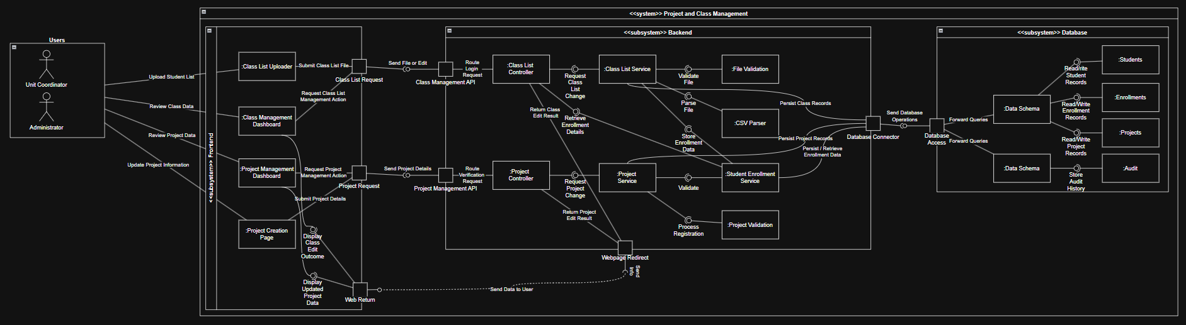
Figure 3.3.4.1 “Project and Class List Management UML Diagram”
There are several key interfaces defined within the Class and Project List Management component, distributed across frontend, backend and database layers. These interfaces enable structured interaction between sub-components while ensuring that only authorised users can manage class and project lists, maintaining separation of concerns and controlled data access.
The Class List Request Port is used by the Class List Uploader and Class Management Dashboard to communicate with the Class Management API. This interface allows the frontend to send class list upload requests, retrieve class list information and receive validation results from the backend.
The Project Request Port is used by the Project Management Dashboard and Project Create Page to communicate with the Project Management API. This interface supports project creation, project updates and project retrieval, allowing project information to be managed through controlled frontend requests.
The Class Management API acts as the backend access point for class list related functionality. It receives requests from the Class List Uploader and Class Management Dashboard, then passes them to the Class List Controller for processing.
The Project Management API acts as the backend access point for project related functionality. It receives project requests form the project Management Dashboard and Project Creation Page, then forwards these requests to the Project Controller.
The Class List Controller coordinates the backend flow for class list actions. It depends on the Class List Service to perform business logic, the Webpage Redirect Port to return information to the users after actions and the Student Enrollment Service to create or update student enrolment records.
The Project Controller manages project related requests. It depends upon the Project Service for project processing and the Webpage Redirect Port to supply information back to the user after project actions are completed.
The Class List Service contains the main business logic for processing and uploading class lists. It depends upon the FIle Validation system to check the uploaded file, the CSV Parser system to ingest the data into memory, the Student Enrollment Service to manage enrolment records and the Database Connector Port / Database Access Port to persist and retrieve information.
The Project Service contains the main business logic for creating and maintaining project records. It depends upon the Student Enrolment Service to ensure projects are linked to valid enrolled students here required, Project Validation to check project details and the Database Connector Port / Database Access Port to save and retrieve project data.
The Student Enrollment Service manages student and enrolment information used by both class list and project workflows. It depends upon the Database Connect Port / Database Access Port to access required student and enrolment records.
Overall, the UML diagram shows how the Class and Project List Management system is separated into distinct frontend, backend and database responsibilities. This helps support maintainability, validation, RBAC permissions and reliable management of student enrollments and project data within the Curtin Group Allocation System.

4.3.5 Functional Services
The Class and project List Management component provides several core functional services to Unit Coordinators and Administrators. They are:
- The ability to upload class lists via CSV files for ingestion into the system
- The ability to validate uploaded class list data, including detection of missing fields, invalid formats and duplicated records.
- The ability to create and maintain student enrolment records linked to specific units.
- The ability to create new projects within refined attributes such as title, description, capacity and description.
- The ability to edit, update and manage existing project information throughout the project lifecycle.
- The ability to validate project data to ensure completeness and logical consistency before information is persisted.
The ability to retrieve validated project data for use in downstream components such as application round and group allocation
- The ability to log and audit key actions such as class list uploaded and project modifications for traceability
The Class and Project List Management component also allows actors with Administrator access the ability to view and oversee class lists, student enrolments and project data. This supports governance, auditing and ensures that data integrity is maintained across the application.

4.4 Theory of Operations
The Class and Project List Management component operates through a structured runtime flow involving frontend interfaces, backend controllers, service-layer logic and database interactions. Each feature follows a consistent pattern where user actions are received, validated, processed and either stored or returned with feedback. This ensures that all interactions are handled reliably and that data remains accurate throughout the system .
The Class List Upload feature begins when a Unit Coordinator submits a file through the Class List Uploader. This request is sent through the Class List Request Port to the Class Management API and handled by the Class List Controller. The Class List Service then validates the file, parses the CSV data and processes each student through the Student Enrolment Service to insert or update records. Valid data is stored in the database, while any errors are returned to the user. This supports functional requirements for uploading and validating class lists, while also meeting non-functional requirements such as data integrity and usability.
The Class Management Dashboard allows coordinators to view and verify enrolment data. When accessed, a request is sent through the Class List Request Port and processed by the Class List Controller and Service, which retrieve data from the database and return it to the frontend. This enables real-time visibility of student enrolments and supports performance and usability requirements, as well as the user need to confirm class data.
Project Creation and Management is handled through the Project Management Dashboard or Project Creation Page. Requests are sent via the Project Request Port to the Project Management API and then to the Project Controller. The Project Service validates project details such as required fields and capacity before saving them to the database. After processing, the user is redirected back to the interface with confirmation. This ensures projects are accurate and complete, supporting both functional requirements and non-functional requirements like consistency and reliability.
Project retrieval is used by other components, such as application rounds and group allocation, to access project data. Requests are handled by the Project Controller and Service, which return only validated and active projects from the database. This ensures downstream components operate on correct data and supports system-wide consistency and interoperability.
The Student Enrolment Service acts as a shared dependency across features, ensuring that student records are consistent and correctly linked to units. It validates student existence and maintains enrolment relationships, preventing duplication and ensuring referential integrity across the system. This supports both functional consistency and non-functional maintainability.
Audit logging is performed during key operations such as uploads and project updates. The Audit Service records each action with relevant metadata and stores it in the database, allowing system activity to be tracked. This supports security and accountability requirements and enables administrators to review changes when needed.
Overall, the component follows a consistent execution flow where user actions are initiated in the frontend, processed through defined interfaces and services, and result in database interactions followed by a response or redirect. This structured approach ensures the component meets its functional requirements, supports non-functional requirements such as usability and performance, and integrates effectively within the Curtin Group Allocation System.

4.5 Security and Ethics
Although the Class and Project List Management component is not primarily focused on cybersecurity, it still handles sensitive student and project data and therefore requires basic security measures. Access is controlled through integration with the User Management System, ensuring that only authorised roles such as Unit Coordinators and Administrators can perform actions like uploading class lists or managing projects. All incoming data is validated before processing, including file validation for uploads and field validation for project creation, helping to prevent invalid or inconsistent data from entering the system. In addition, database interactions are handled through controlled interfaces, and key actions are recorded through audit logging to provide traceability and accountability.
From an ethical perspective, the component must ensure that student data is used appropriately and only for its intended academic purpose. Access to enrolment and project data is restricted to relevant roles, supporting privacy and data minimisation principles. It is also important that project information is accurate and consistently maintained, ensuring all students have equal access to opportunities during application rounds. Overall, the component applies basic security controls and ethical practices to support responsible use within the Curtin Group Allocation System.

5. Architectural Specification – Group Allocation System

5.1 Introduction
This section will cover how the system will allocate groups for the Capstone Computing Project Unit. Group allocation is the process by which each student is allocated to a group at the beginning of the unit. This section covers how the component can interact with the other components and how the component can be implemented.

5.2 Overview
The Group Allocation component is responsible for splitting the students from the student list into Capstone Computing Project groups. The group allocation will be done algorithmically, with some constraints, e.g., students’ preferences and HCI enrolment. Though groups can be manually managed by UCs to give UCs more flexibility in how groups are formed.

5.3 Design Methodology

5.3.1 MVC implementation
- Model
PostgreSQL and Supabase will hold the data structures for groups and group memberships, which will be handled by NestJS.
- View
Vue will render the UI for users. It will also handle user inputs. Students will only be able to view the groups. UCs will be able to view and edit the groups.
- Controller
NestJS will handle the group allocation on the backend. This layer will be responsible for algorithmically allocating groups to students. It will also handle any edits done by UCs from the View layer.

5.3.2 Overall CGAS Integration
This component will be available after the student list, project list, and unit list have been imported. Students will have to wait for the UCs to apply the group allocation to see the group list. The component will mostly be working in the background. Pulling the student list, project list, and unit list from the database. And then using the algorithm to allocate the groups to the students in the background.
The component will then create a draft of the group allocation so that the UCs can moderate the group allocation before finalising it. After the group allocation is finalised by the UC, a group list will be created and pushed onto the database. Which can be viewed by the students and edited by the UCs. The component will interact with the notification system to notify students when the group allocation is released and if there are any changes to a student’s group membership.

5.3.3 Dependency Matrix

Sub-Component | Dependency
Group Creation UI | Group Management Port, Group API Port
Group Management UI | Allocation Management Port, Allocation API Port, Allocation Response Port
Group Allocation Dashboard | Allocation Results Port, Allocation API Port
Allocation Results UI | Allocation Results Port, Allocation API Port
Group Controller | Group Service, Allocation Data Port, Database Access, Webpage Redirect, Allocation Response Port
Allocation Controller | Allocation Service, Allocation Data Port, Database Access, Webpage Redirect, Allocation Response Port
Group Service | Group Validation Service, Membership Service
Allocation Service | Allocation Engine, Allocation Audit Service, Allocation Validation Service
Membership Service | Allocation Data Port, Database Access
Allocation Engine | Allocation Data Port, Database Access
Allocation Audit Service | Allocation Data Port, Database Access
Notification Schema | Tables - Notification, Templates
Application Schema | Preferences Table
Auth Schema | Users Table
Audit Schema | Audit Table

5.3.4 UML Diagrams and Discussion
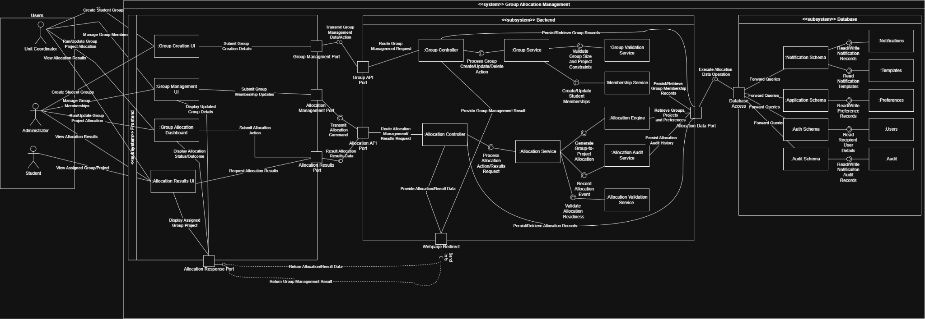
Figure 5.3.4.1 “Group Allocation UML Diagram”
There are several key interfaces defined within the Group Allocation component, distributed across frontend, backend, and database layers. These interfaces facilitate communication between subcomponents to algorithmically allocate groups and show users the group list after the groups are allocated.
The Group Management Port is used by the Group Creation UI to communicate with the Group API. This interface allows UCs from the frontend side to send group creation details to the Group Controller.
The Allocation Management Port is used by the Group Management UI to communicate with the Allocation API. This interface allows UCs to manage group membership, sending the group membership updates to the Allocation Controller.
The Allocation Results Port is used by the Group Allocation Dashboard and Allocation Results UI to communicate with the Allocation API. This interface allows users to retrieve the allocation results and view them.
The Group API is provided by the Group Controller and is consumed by the Group Creation UI via the Group Management Port. It processes group creation details, sending the details to the Group Controller.
The Allocation API is provided by the Allocation Controller and is consumed by the Group Management UI, the Group Allocation Dashboard, and the Allocation Results UI via the Allocation Management Port and the Allocation Results Port. This API can be used to manage the group allocation and view the results of the allocation.
The Allocation Data Port is provided by the database layer and acts as the primary interface for the backend to access the database so that the backend can take the data required for group allocation.
These interfaces allow components to interact with each other securely.

5.3.5 Functional Services
- Group Creation - Enables UCs to create groups according to the group creation details provided by the UCs.
- Group Allocation - Allows the UCs to allocate students to groups algorithmically.
- Group Management - Allows UCs to manually manage the groups. UCs will be able to add groups and delete groups.
- Allocation Results Retrieval - Allows users to see the results of the group allocation.

5.4 Theory of Operations
Before groups are created and allocated, only UCs can access this component. UCs will have to submit the group creation details, e.g., how many members will be in a single group. This will create empty groups according to the number of students, which will be retrieved from the student list in the database.
After the groups have been created, UCs can run the Group Allocation algorithm. This will allocate students into groups according to the students’ preferences, the students’ majors, the students’ unit enrolment, the projects available, the students’ CWA, etc. This works by gathering input from the lists that are stored in the database.
When the algorithm finishes processing the data from the database, the system will show the UC a draft of how the group is allocated. The UC will then either modify or accept the draft. After the group allocation is finalised, the students will be notified.
UCs can then view the results of the group allocation, and the students can see which group they are assigned to.
This covers the Functional Requirement of automatically allocating students to Capstone Computing Project groups. Eliminating the need for UCs to create groups manually.

5.5 Security and Ethics
This component can handle sensitive student data. Therefore, the component will have to adhere to Curtin University’s security requirements. One of the ways to adhere to security requirements is to not show a student’s name and their student ID together to other students when showing the group list to students, as that counts as a security breach. Students’ CWAs will also be hidden as that is private information.

6. Architectural Specification - Student Information System

6.1 Introduction
This chapter will cover the proposed Student Information System component. The chapter will discuss what the component encompasses in functional terms, how the component interacts with the wider component ecosystem, and a cursory overview of how the component is likely to be implemented. The chapter will also include illustrations where relevant to provide additional contextual information to the reader.

6.2 Overview
The Student Information System is a component of the CGAS oriented to for use by primarily Student actors. The scope of the Student Information System is to provide Student actors with a portal to provide, view and update their personal information and CV/cover letter(s). Additionally the Student Information System is meant to provide Student actors with a dashboard to view their current groups, applications and classes they are currently a part of. However, management and interaction with the latter features is beyond the scope of the Student Information System.

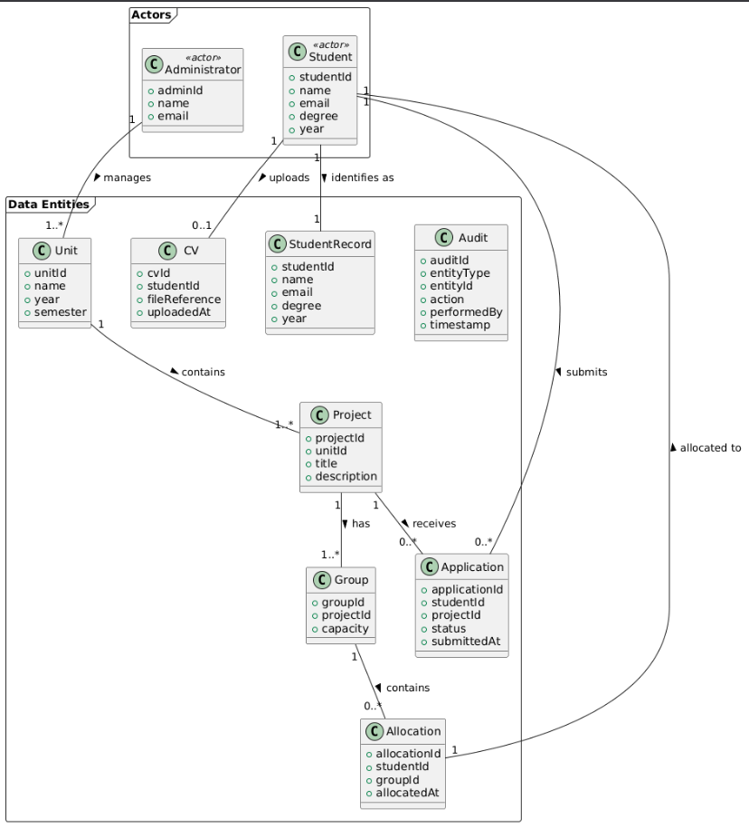
Figure 6.2.1 “Student Information System Domain Diagram”

6.3 Design Methodology - Talk about how your techstack interacts with the component

6.3.1 MVC implementation
The Student Information component has several features that will be divided across the MVC layers.
All sub-components within the Database grouping fall under the Model layer, with it consisting of 3 schema:
- Data Schema
- Application Schema
- Audit Schema
The Data Schema will store the Student and Project tables, the application schema will store the Applications, Groups and Allocation tables and the Audit Schema will contain the Audit table. Backend services will interact with these schemas via the Database Access Component and Student Information Data Port, ensuring that all data operations remain abstracted from their controllers.
The subcomponents under the Frontend group fall under the View layer, which is also comprised of 3 sub-components:
- CV Uploader
- Student Profile UI
- Student Dashboard UI
These sub-components all serve to present data to users (primarily students), capture their input as well as communicate with the backend sub-component grouping exclusively via 3 defined ports to APIs. These ports are:
- CV Uploader Port
- Information Retrieval Port
- Web Return Port
The configuration and usage of such ports by sub-components within the View layer (as opposed to direct access), helps to ensure the Student Information System remains loosely coupled and portable.
The Controller layer is composed of 2 controllers: Profile Controller and Dashboard Controller. The Profile Controller receives requests via the Profile API, with it routing retrieval and upload requests to the Profile Service. The Dashboard controller receives requests via the Dashboard API, and routes retrieval and upload requests to the Dashboard Service. Both controllers return their results to their corresponding View layer sub-components via the Webpage Redirect Port. This way, both controllers act as the intermediaries between the view and service layers of the Student Information System, enforcing separation of presentation and business logic within the component.

6.3.2 Overall CGAS Integration
As stated previously, the Student Information System is incorporated into the wider CGAS as a central node for Student actors to receive, view and potentially alter information regarding themselves and matters that affect them. In order to do this, the component needs to interact with the CGAS database. However, the connection to the database is the extent to which the Student Information System interacts with the wider CGAS ecosystem. The component is not aware of other components within the web application’s architecture, and has no means of communicating directly to them. This also means that the rest of the system, excluding the database, are also unaware of the Student Information System's existence as well. The only exception to this isolation is the External File Storage Service, which it needs to be able to communicate with in order to send, update or pull stored CVs
.

6.3.3 Dependency Matrix

Sub-Component | Dependency
CV Uploader | CV Upload Port
Student Profile UI | Information Retrieval Port, Profile API, Web Response Port
Student Dashboard UI | Dashboard Retrieval Port, Dashboard API, Web Response Port
Profile Controller | Profile Service
Dashboard Controller | Dashboard Service
Profile Service | Student Information Port. File Validation Service, Profile Validation Service
Dashboard Service | Student Information Port,
File Validation Service | File Storage Port
Profile Audit Service | Audit Schema
Student Information Data Port | Data, Applications and Audit Schemas
File Storage Port | File Storage Service (External)
Data Schema | Students and Projects Tables
Application Schema | Application, Groups and Allocations Table
Audit Schema | Audit Table

6.3.4 Interface Discussion
There are 10 proposed interfaces for the Student Information System, spread across all 3 of the sub-component groupings.
CV Upload Port is used by the CV Uploader to transmit CV or cover letter documents in PDF format to the Profile API in the backend. This relationship is one-way.
Information Retrieval Port is used by the Student Profile UI. This port transmits retrieval and edit requests, and is consumed by the Profile Controller. The relationship is defacto one-way, with responses instead being delivered via the Web Return port. Data is delivered in a JSON format.
Dashboard Retrieval Port is used by the Student Dashboard UI. This port transmits retrieval requests, and is consumed by the Dashboard Controller. The relationship is defacto one-way, with responses instead being delivered via the Web Return port. Data is delivered in a JSON format.
The Web Return Port is provided by the Student Dashboard and Profile UIs. This port receives fulfilled responses from the backend via the Webpage Redirect Port, and delivers them to the corresponding frontend sub-component. The relationship is one-way, with data being delivered in a JSON format.
The Webpage Redirect Port is provided by the Profile and the Dashboard Controllers. It is consumed internally by the backend controllers to transmit fulfilled responses back to the frontend. The relationship is one-way, with the data being exchanged in a JSON format.
The Profile API is provided by the Profile Controller sub-component. The API is consumed by both the Student Profile UI and the CV Uploader via the Information Retrieval Port and the CV Upload Port respectively. This relationship is a request-response type, with the data exchanged being either of JSON or PDF formatting.
The Dashboard API is provided by the Dashboard Controller sub-component. The API is consumed by the Student Dashboard UI via the Dashboard Retrieval Port. This relationship is also a request-response type, with the data being exchanged being of JSON formatting.
The Student Information Data Port is provided by the Database sub-component grouping. The port is the sole access point for backend sub-components to read and write from the Database-grouped schemas. The relationship is request-response, with services submitting structured queries and receiving records in return.
The File Storage Port is provided by the External File Storage Service. It is consumed by the FIle Validation Service sub-component, with it handling CV/cover letter transmission after the service has acted on it. The relationship is two-way, with uploads being of a PDF format and retrievals as signed URLs.
The Database Access Port is provided by the Database grouping, and acts as the internal gateway to the stored schemas and tables. It is indirectly consumed by all backend services that require data persistence or retrieval. The relationship is a request-response type, with the port abstracting query operations from consuming services and handling structured data access internally.

6.3.5 Functional Services
The Student Information System provides 5 main functional services to the student user group. These are:
- The ability to view and update their profile data on the platform
- The ability to receive an overview on the student’s current application round status, group information (if present) and class
- The ability to upload a CV or cover letter in PDF format to their profile for consideration by faculty
- Format validation for CV and profile alterations
- Auditing services for individual profiles
The Student Information System also allows actors with the Administrator access level the ability to view a Student actor’s profile. This is primarily for oversight reasons, but also serves to allow the Administrator(s) to have a wider holistic view of the way the CGAS functions for Student Actors.

6.4 Theory of Operations
In all possible flows for the Student Information System component, the front end grouping of subcomponents have no direct knowledge of the database, nor any external systems (such as the FIle Storage Service). All data operations are mediated by the backend-grouped controller and service layers. Persistence is handled via dedicated ports, ensuring that coupling between internal structures and interfaces remains minimal.
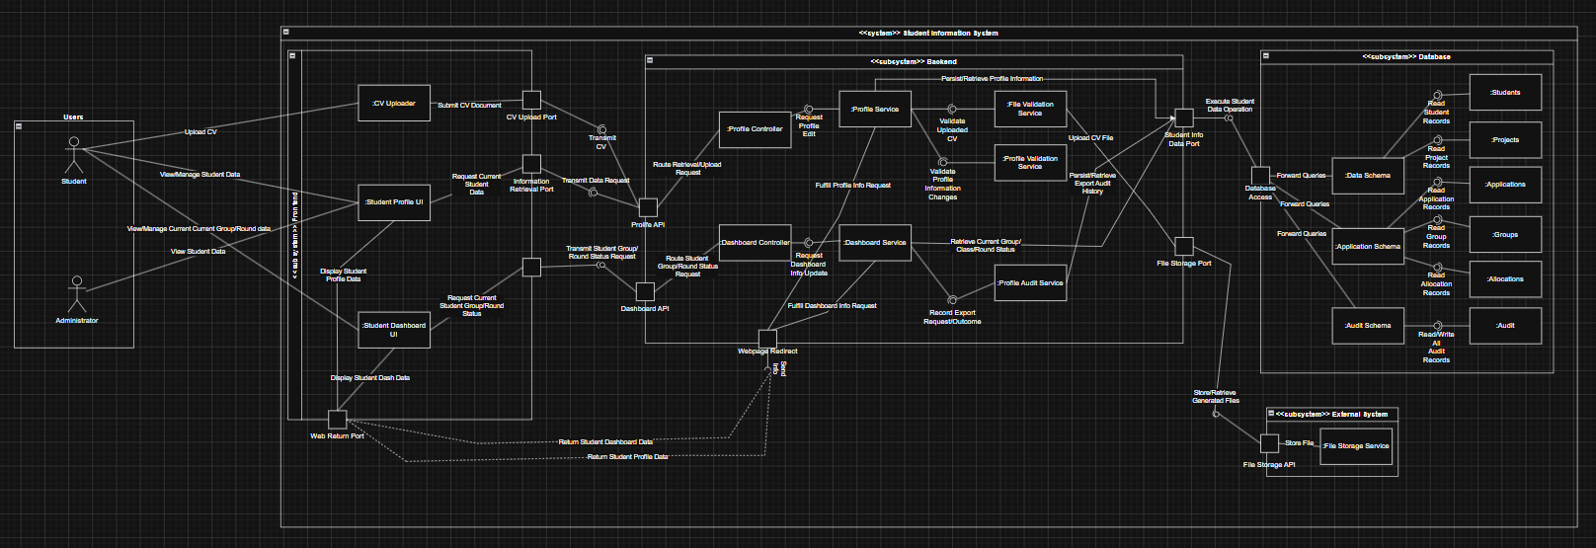
Figure 6.4.1 “Student Information System Component Diagram”

6.4.1 Profile Flow (Student)
A Student actor can initiate a profile action from the Student Information component. This action can be either uploading/replacing a CV or cover letter document, or viewing/editing their data held for in their profile. The action is taken through either the Student Profile UI, or the CV Uploader UI subcomponents within the front end of the application.
The CV Uploader will submit an uploaded PDF file. Which is then transmitted from the CV Upload Port to the Profile API. The Student Profile UI will make a request for the current data associated with the student’s profile. This data request is routed to the Information Request Port, and is also received by the Profile API. In both action cases, the request will be routed to the Backend’s Profile Controller. The controller will then determine whether the request is a retrieval or edit operation, and routes it accordingly to the Profile Service.
For document uploads, the Profile Service will first pass the operation to the FIle Validation Service. This service ensures that the document to be uploaded is of the correct file type (PDF). The Profile Service will also utilize the Profile Validation Service to ensure that the student’s profile remains valid after this latest modification to it. Once this has been completed, the CV/Cover Letter file is then sent to the File Storage Port to be uploaded to the external File Storage Service via its API.
For student profile viewing, editing and CV retrieval, the information request is routed to the Student Information Data Port (with profile changes first being validated by the Profile Validation Service). The Database will then access and retrieve/update the relevant tables. If the operation is a retrieval, the information request is then retransmitted back to the Student Information Data Port and onto the Profile Service. From there, the fulfilled information request is routed to the Webpage Redirect Port in order to send the info back to the Student Profile UI in the front end (via the Web Return Port).

6.4.2 Dashboard Flow (Student)
A Student actor can access their dashboard through the Student Dashboard UI. This sub-component requests the current student group, class, and application round status. This request is routed through the Dashboard Retrieval Port and onto the backend’s Dashboard API. This request is then processed by the Dashboard Controller.The service will then forward the request to the relevant schema via the Student Information Data Port/Database Access connection. Once the requested information is retrieved, the fulfilled request is then sent back to the Dashboard Service via the same route, before being retransmitted back to the Student Dashboard UI via the Webpage Redirect-Web Return Port.

6.4.3 Profile Flow (Administrator)
An Administrator actor is also able to view a Student actor’s profile by accessing the Student Profile UI sub-component within the front end grouping. The process of retrieving this data for viewing is the same as mentioned in section 6.4.1. The Administrator actor however would be unable to edit any data stored within this profile, including any CVs or cover letters attached to it.

6.5 Security and Ethics
The Student Information System component of the CGAS by its nature has several ethical and security concerns that need to be addressed. The system requires students to provide their personal data in order for the CGAS to function as intended. As such, our web application must comply with Australia’s Privacy Protection Act (1988).
The collection of such data complies with the act’s APP 3 of it being reasonably necessary for the system to function. This is because without such data being provided, the ability for faculty to determine class, group and project allocation would be impossible.
Steps will be taken to ensure that any data collected by the CGAS will remain reasonably secured against potential bad actors or cyberthreats. The employment of PostGRE SQL to store the collected student data will provide the CGAS database(s) a robust and industry standards foundation. This, when configured with the appropriate access controls and encryption, will support the CGAS's compliance obligations under the Privacy Protection Act. More information on the use of PostGRE SQL in our technology stack can be found in the accompanying TIS document.
Students would also have the option to read the client’s Privacy Policy before registering, which should include a notification and disclosure of usage on how and when their information will be collected. Registration with the CGAS will be taken as agreeing to this policy.

7. Architectural Specification - Application Round Management

7.1 Introduction
This section focuses on the Application Round Management component of CGAS. It highlights the processes involved in creating, distributing and overseeing application rounds for student project selection. It will also explain how this component connects with other parts of the system and its role in collecting and evaluating student applications.

7.2 Overview
The Application Round Management is responsible for managing the lifecycle of application rounds. This involves the Unit Coordinators creating the application, students submitting applications, and the review of applications.
The Unit Coordinator can define the parameters involved in creating the application. For example, these parameters include setting availability periods (when it opens and closes), and list the available projects. Students can interact with the applications by submitting an ordered list of preferences for each project. Unit coordinators can then review all the applications.

7.3 Design Methodology
The established technologies will be used to create and handle the Application Round Management component.
Vue.js, the frontend technology, will provide users with interactive interfaces. For example, this interface must allow Unit Coordinators to run application rounds (with parameters) and allow them to review submitted applications. Students must have an interface that allows them to interact with projects and select a preference for each project.
The NestJS technology handles the backend app logic after receiving incoming requests from the frontend. This involves validating application data, enforcing deadlines and managing application states. This ensures the correct execution of the workflow.
Supabase will ensure that secure authorisation and communication occur on the server. This is achieved by only allowing authorised users to access the application rounds, and each user has a role that changes their permissions. The storage of applications is done by PostgreSQL, which stores details such as the application round number and student preferences.

7.3.1 MVC implementation
Following an MVC implementation for Application Round Management:
- The Model layer will use PostgreSQL and Supabase to store related data to applications. This includes application rounds, applications, and student preferences. It will also contain the relationship of data between Students and Unit Coordinators, store deadlines, and stored data will be checked to ensure data consistency.
- The View layer will use Vue.js to provide an interface for users to input data that can be captured and processed. For students, this interface will contain the application submission UI, the student users’ application status, and the preference selection UI. For the Unit Coordinators Application Round UI for creating and an application dashboard for reviewing and seeing the status of all applications.
- The Controller layer will use NestJS to receive user input from the frontend and use this to manage workflow logic. This includes creating rounds, submitting applications and retrieving application data.

7.3.2 Overall CGAS Integration
The Application Round Management serves as a bridge between data preparation components and downstream allocation processes.
This is because the Application Round Management first relies on the Class and Project List component to provide valid project and student data. Without this data, none of the applications can be created because there are no projects and neither can they be populated since there are no students.
The Application Round Management requires the Student Information System to provide student profile data. This data allows applications to access student details like their ID’s and what course they are studying.
The Group Allocation component interacts directly with the Application Round Management component. After either all students have uploaded their preferences or applications close at the end date. All applications are then sent to the Group Allocation system, which uses an algorithm to ensure equal groups in numbers and varying degrees while using student preferences.
Finally, the Notification component also interacts with the Application Round Management. For example, whenever applications start or end dates are approaching, users need to be notified. Also, whenever the application status changes, users should also be notified.

7.3.3 Dependency Matrix

Sub-Component | Dependency
Application Round UI | Round Request Port, Round Management API
Application Submission UI | Application Request Port, Application API
Preference Selection UI | Preference Request Port, Preference API
Application Dashboard | Application Retrieval Port, Application API
Round Controller | Round Service, Webpage Redirect Port
Application Controller | Application Service, Webpage Redirect Port
Preference Controller | Preference Service, Webpage Redirect Port
Round Service | Round Validation, Database Access Port
Application Service | Application Validation, Database Access Port
Preference Service | Preference Validation, Database Access Port
Database Schema | ApplicationRounds, Applications, Preferences Tables

7.3.4 Interface Discussion
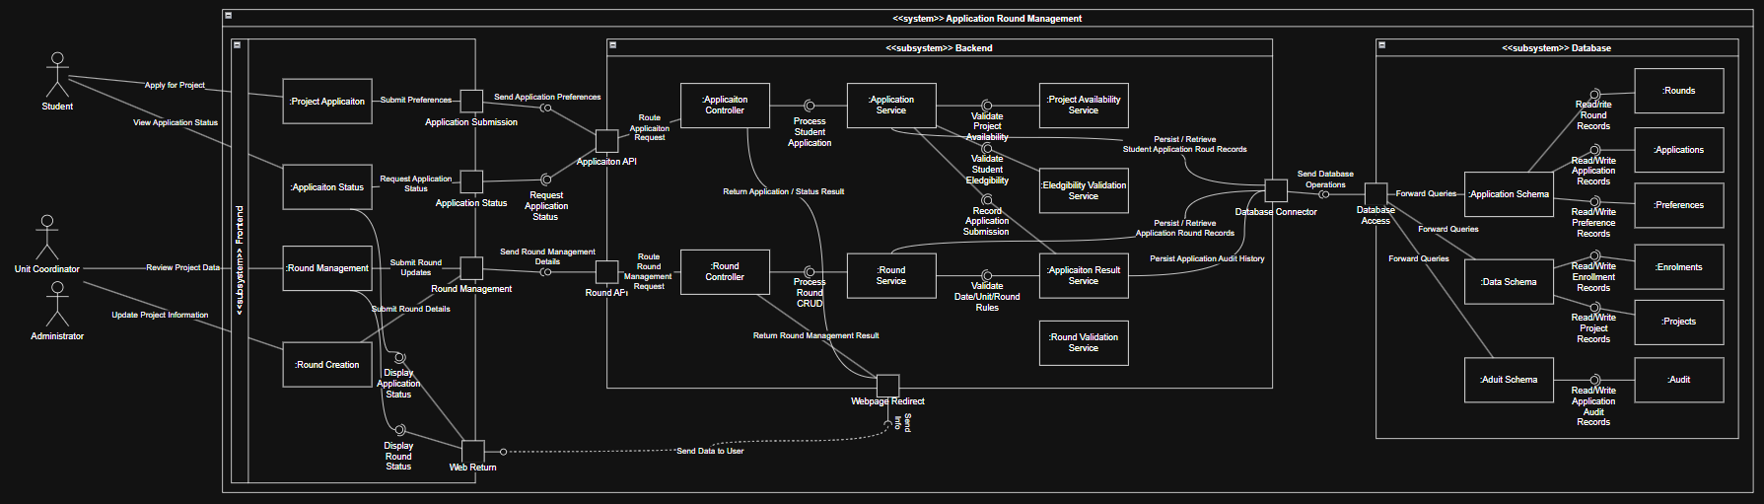
Figure 7.3.4 “Application Round Management Component Diagram”
The UML diagram for the Application Round Management component shows the interactions between the frontend interfaces, backend controllers and database services.
Students can apply for projects via the Project Application UI in the frontend. The Application Submission Port sends student preference data to the Application API, where backend functionality handles the logic of this data. Similarly, students can also view application status, where the Application Status Port is used to request student status, also via the Application API. Then the web returns data to the user so they can see their status.
The Round Management UI and Round Creation UI are used by the Unit Coordinators to create, update and manage applications which then travel through the Round Management Port. This port is then linked to the Round API to connect the frontend to the backend.
The Web return point is used to send data to users via the UI interfaces to display data like application status. It however, first must receive responses from the backend controllers.
Application API is provided and used by the Application Controller. The Application API takes frontend data and routes application requests to the Application Controller in the backend services, where input is validated to store and retrieve data.
The Database access point is used by backend services so that these services can interact with the database layer. It stores application rounds, applications, and preferences from the Application Schema.

7.3.5 Functional Services
The Application Round Management has these core functionalities:
- Unit Coordinators can create and manage application rounds
- Definition of round parameters like availability periods and associated projects
- Students can submit applications
- Support project preferences within applications for students
- Applications are validated to ensure correctness
- Retrieval and display of application data for students and unit coordinators
- Unit coordinators can review and manage applications
- Automatic deadline and round closure enforcement
- Supply application data downstream to the Group Allocation component
- Logging and auditing of application-related actions for traceability

7.4 Theory of Operations
The Application Round Management component has a structured runtime flow involving the frontend interfaces, backend processing and database interactions.

7.4.1 Application Round Creation
The first process begins with the Unit Coordinator, who creates a round through the Application Round UI. The Round Request Port sends a request to the Round Management API, which is handled by the Round Controller, where the data is validated before being saved to the database.

7.4.2 Application Submission
Once the round is open, students can submit their applications through the Application Submission UI. Students will include their preferences in the application. Their application is then sent to the backend, where it will be checked against methods like checkDeadline() and validateApplication(). If the submission passes checks, then it is stored in the database.

7.4.3 Application Status Retrieval
Students can view their application status through the Application Dashboard. First, a request has to be sent to the Application API, which retrieves relevant data and is then returned to the frontend via the Web Return Port.

7.4.4 Round Closure and Review
After the application round closes, the system will automatically stop accepting submissions. Then, Unit Coordinators can review all the applications through the management interfaces.

7.4.5 Integration with Group Allocation
The validated applications and data are then available to be accessed by the Group Allocation component, which can then be used to form groups.

7.5 Security and Ethics
The Application Round Management component must comply with security and ethical standards.
Role-based access should be used. This means only authorised users can perform specific actions. For example, Unit Coordinators can create and manage application rounds, while Students cannot and are limited to submitting and viewing only their applications.
All data must also be transmitted over a secure HTTPS connection to ensure its security. Data must also be validated in order to prevent invalid or malicious code from being injected into the system.
The system is ethical because it provides students with a fair and transparent application process. All students are given equal access and the same defined timeline to ensure fairness. Also, Student data is used only for academic purposes, which supports privacy.
Audit logging is also implemented to track keystrokes, ensuring traceability and accountability in the system.

8. Architectural Specification – Notification System

8.1 Introduction
This chapter will cover the proposed Notification System component of the CGAS. THe Notification System provides key functionality to the CGAS, as it is intended to be the primary mode of communication between the platform’s user groups. The chapter will outline how the component will be logically structured as well as discuss the most likely route of implementation. Illustrations (primarily UML based) will also be present throughout the chapter in order to provide additional contextual information to the reader.

8.2 Overview
The Notification System Component’s role within the CGAS is broad in scope, with it meant to cover automated, in-platform notifications and the transmission of such notifications to actor accounts.. This component is meant to be accessible to all human actors (Students, Administrators and Unit Coordinators). Additionally, the Notification System is responsible for dispatching email-based notifications to the relevant actors via Brevo in accordance with each actor’s stored notification preferences.
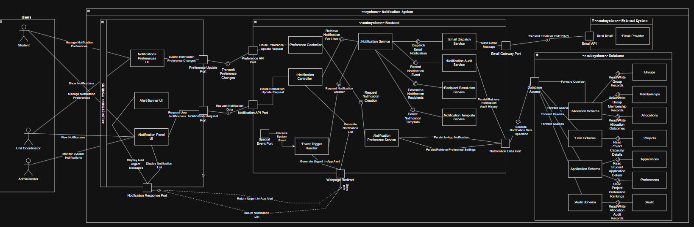
Figure 8.2.1 “Notification System Component Diagram”

8.3 Design Methodology

8.3.1 MVC implementation
The Notification System component divides its sub-components based on the MVC pattern of system architecture, with each layer being developed to ensure that clear separation of concerns between sub-components is maintained.
Database Layer - The following Database grouping of sub-components falls under MVC’s Model layer. All of these sub-components will be implemented with PostgreSQL, and hosted with Supabase. The Data schema stores the Projects, Applications and Preferences tables, with the Preferences table being the table that holds each user’s notification preference settings. The Application schema stores application-related data that may be referenced during the notification creation, such as retrieving a list of applicants for a project when creating a notification regarding said project.
The Allocation schema stores the Groups, Memberships and Allocation tables. The schema is meant to hold the various structures that students have been assigned to, such as project groups or units. The Audit schema will contain the Audit table, which in turn stores all of the records created by the Notification Audit Service for notifications. The schema will be managed by PostgreSQL, with Supabase being used to host the database and associated external File System. The
View Layer - The frontend grouping’s 3 sub-components serve as the View Layer for this component. The layer will be implemented with Vue.js, and rendered as HTML in the user’s browser of choice. The Notification Preferences UI presents the current user’s notifications preference settings, and is also able to capture alterations to these settings. The Notification Panel UI serves as an inbox of notifications addressed to the user. The Alert Banner UI on the other hand provides a dedicated, highly visible banner on the user’s screen for notifications that have an urgent viewing priority. The banner can however be dismissed at the user’s will.
Controller Layer - This layer is composed of two controllers present in the backend of the Notification System: The Preference Controller and the Notification Controller. Both of these controllers will be implemented with Javascript, and executed on Node.Js runtime. The Notification Controller will receive notification creation and retrieval requests via the Notification API port, and will route them to either the Notification Service or the Webpage Redirect Port depending on the fulfillment status of the request. The Preference Controller will receive preference retrieval and update requests via the Preference API port, with it then routing them to the Notification Preference Service for handling.

8.3.2 Overall CGAS Integration
The Notification System component integrates into the wider CGAS system to provide event-driven, automated notifications to each registered client. This component has a higher level of dependency on other components within the CGAS system due to relying on the schemas populated by said components. Without access to these schemas, the Notification System has no contextual information and events to draw upon when creating or distributing notifications.
The component will also utilize the third-party email service Brevo. The use of Brevo allows both the system and Unit Coordinator Actors to create and transmit mass email notifications. It can also potentially provide templating services to supplement the component’s own existing service.

8.3.3 Dependency Matrix

Sub-Component | Dependency
Notification Preferences UI | Preference Update Port
Alert Banner UI | Notification Response Port
Notification Panel UI | Notification Request Port, Notification Response Port, Notification API
Preference Controller | Notification Preference Service
Notification Controller | Notification Data Port
Event Trigger Handler | Special Event Port
Notification Service | Email Dispatch, Notification Audit, Recipient Resolution and Notification Template Services.
Notification Preference Service | File Storage Port
Email Dispatch Service | Audit Schema
Notification Audit Service | Data, Applications and Audit Schemas
Recipient Resolution Service | None
Notification Template Service | None
Email Gateway Port | Email API (External)
Notification Data Port | Database Access Port
Data Schema | Projects Table
Applications Schema | Applications and Preferences Tables
Allocations Schema | Application, Groups and Allocations Table
Audit Schema | Audit Table

8.3.4 Interface Discussion
There are 11 proposed interfaces for the Notification System, spread across all 3 component groupings. These are as follows:
The Preference Update Port is utilized by the Notification Preferences UI to transmit notification preference alteration and retrieval requests to the backend’s Preferences API. The relationship is de facto one-way, as responses are returned via the Notification Response Port as opposed to the Preference Update Port. The data format used for information exchange is JSON.
The Notification Request Port is used by the Notification Panel and Alert Banner UIs to transmit notification retrieval requests to the backend’s Notification API. The relationship is de facto one-way, as responses to any requests are transmitted back via the Notification Response Port. The formatting for transmitted data is also JSON.
The Special Event Port is utilized by external system processes to transmit system-generated events to the Event Trigger Handler. The relationship is one-way, with event payloads delivered in JSON format.
The Notification Response Port is consumed by both the ALert Banner and the Notification Panel UI sub-components. It is responsible for performing the final leg of response transmission from the backend to the aforementioned sub-components. The relationship is one-way, with data being delivered in a JSON format.
The Webpage Redirect Port is provided by the Notification Controller and Event Trigger Handler. The backend controllers utilize it to fulfill response toward the frontend via the Notification Response Port. The relationship is one-way, with data transmitted in JSON formatting.
The Preference API is provided by the Preference Controller. It is consumed by the Notifications Preferences UI via the Preferences Update Port, with the frontend sub-component interacting exclusively with the port rather than the API directly. This relationship is of a request-response type, with data being exchanged in a JSON format.
The Notification API is provided by the Notification Controller. It is consumed by the Notification Panel and the Alert Banner UIs via the Notification Request Port rather than via direct communication. The relationship is also request-response, and handles data in a JSON format.
The Email Gateway Port is provided by the user’s external email provider, and is consumed via the Email Dispatch Service. It transmits outbound email messages to the Email Provider, via an SMTP API. The relationship is de facto one-way, though the port does receive a delivery confirmation upon successful transmission. The data being exchanged consists of formatted email payloads.
The Notification Data Port is provided by the Database sub-component grouping, and acts as the sole access point in which backend services can read/write to/from the database-grouped schemas. It is consumed by the Notification Preference Service, Notification Audit Service and Notification Service. The relationship is request-response based, and utilizes structure queries for submission and returns records.
The Database Access Port is provided by the Database subsystem, and acts as the internal gateway between the Notification Data Port and the stored schemas/tables. As such, the port is indirectly consumed by most backend services. Data persistence and retrieval operations/queries are all routed to the required schema. The relationship is request-response, with the component abstracting schema level operations from consuming services.
The Email API is provided by the external Email Provider, and is the outermost interface in the Notification System’s email dispatching chain. It is consumed via the Email Gateway Port, and handles the physical transmission of email messages to recipients. The relationship is one-way outbound oriented, with the data being transferred over SMTP.

8.3.5 Functional Services
The Notification System component provides 7 key functional services to the wider CGAS:
- The creation and transmission of both in-application and email-based notifications
- Notification preference options for users to alter based on their wants
- A central notification inbox accessible on the web application
- The ability to distribute mass, automated notifications to target user groups
- Auditing and logging services for emails and notifications handled by this component
- The ability to utilize templates during the creation of notifications.
- The ability to create and easily view notifications with a high viewing priority
Although Administrator actors are not the primary intended users of this system, they will still have the ability to monitor notifications sent by CGAS users. This is to ensure that the Notification System is not used maliciously, and provides an added layer of oversight for the client to utilize.

8.4 Theory of Operations
The Notification System component facilitates primarily automated, event-based communication between all users on the platform. This request is then parsed by

8.4.1 Preference Editing Flow
Any edit request made by either a Student or Unit Coordinator actor will be via the Notifications Preferences UI, which is then transmitted to the backend’s Preference API via the Preference Update Port. This request is then forwarded by the Notification Preference Controller to the Notification Preference Service, which in turn delegates the persistence of the updated preference settings to the database via the Notification Data and Database access Ports. The Notification Audit Service then records the change event to the AUdit schema, and a confirmation response is returned to the Notification Preferences UI via the Webpage Redirect and NOTification Response Ports.

8.4.2 Notification Viewing Flow
Any actor wishing to view their notifications will do so via the Notification Panel UI sub-component. The Notification Panel UI submits a retrieval request via the Notification Request Port to the Notification API port in the backend group. The Notification Controller receives this request, before forwarding it onto the Notification Service. The Notification Service then coordinates with Notification Preference Service to retrieve the actor’s current preference settings and the Recipient Resolution Service to confirm the actor as a valid recipient for the notifications being retrieved.
The Recipient Resolution Service queries the Allocation Schema via the Database access and Notification Data Ports to resolve the eligibility question. An assembled notification list is then returned to the Notification Panel UI via the Webpage Redirect and Notification Response Ports for display

8.4.3 Notification Dispatch Flow
The Notification System is primarily oriented for system-initiated notification flows. These flows are triggered when events matching the trigger conditions for a notification occur, such as when Unit Coordinator makes Capstone projects available for application. Following this example, the Event Trigger Handler would receive the event via the Special Event Port. The handler would then generate a notification creation request, which is then routed to the Notification Controller. The controller then forwards this as a notification creation request to the Notification Service, which then conducts the full dispatch sequence across its subordinate services.
The Notification Service first consults the Recipient Resolution Service in order to determine the appropriate recipients for the notification. This is resolved by the Recipient Resolution Service querying the Allocation Schema via the Notification Data - Database Access Port connection. Group, Membership and Allocation Tables are accessed in order to identify the relevant actors. The stored notification preferences are also accessed to ensure that the notification adheres to recipient exclusion lists. The Notification Template Service is then consulted to select the appropriate template to use for the notification.
Once all the services have been consulted, the Notification Service proceeds with the dispatch. For web-application based notifications, the payload is persisted via the Notification Data Port. For email-based notifications, the payload is forwarded to the Email Dispatch Service. This service formats the payload to an email, before sending to Brevo’s API via the Email Gateway Port and to its recipients.
Throughout this process, the Notification Audit Service records each notification event and outcome in the Audit Schema in order to ensure traceability is preserved.

8.5 Security and Ethics
Compared to the other components within the CGAS, the Notification System has less ethical and security concerns that need to be taken into account for its development. The main concerns for this component are:
- The usage and protection of user email accounts linked to the CGAS
- The collection and storage of user notification preferences
- The maintenance of a comprehensive audit log
As the development and primary employment of the CGAS is occurring within an Australian domain, the federal Privacy Protection Act (1988) and their accompanying APPs need to be considered. Providing the registered email addresses of actors to Brevo for the purpose of dispatching email-based notifications to them falls within the acceptable bounds of APP 6, which governs the usage and disclosure of Personal information. This is because the purpose for this disclosure is to provide a service that the actor has consented to. However, the use of Brevo as a third-party provider will need to be disclosed in the privacy policy of CGAS.
The retention of notification audit records in the Audit schema will require a defined and justifiable retention period, along with a data disposal plan. These are required for compliance with the Act, as data cannot be retained for longer than what is deemed necessary by the organisation.
The storage of user notification preferences will be Act compliant as the database that holds the preferences will be encrypted and incorporate appropriate access controls.

9. Architectural Specification – Reporting and Export Management

9.1 Introduction
This section covers the Reporting and Export Management component of the Capstone Group Allocation System. It will discuss how the component is structured, how it interacts with other components, and how it can be implemented.

9.2 Overview
The Reporting and Export Management component is responsible for allowing UCs and Administrators to generate, preview, and download data from the system, such as, group allocations, project lists, audit history, etc. The component handles the full lifecycle of an export request. The component reads data from the database then generates a file from it. Generated files will be stored on an external File Storage Service which is also where users can retrieve the files from.

9.3 Design Methodology

9.3.1 MVC implementation
- Model
PostgreSQL and Supabase will hold the data structures for student records, applications, group allocations, and audit entries, which will be managed by NestJS. Generated files will be stored in an external File Storage Service.
- View
Vue will render the UI for users. It handles user inputs like filters and types. UCs and Admins can request exports, view export history, and download generated files. Students do not have access to this component
- Controller
NestJS handles export and report generation on the backend. This layer is responsible for validating requests, coordinating data retrieval and file generation.

9.3.3 Dependency Matrix

Sub-Component | Dependency
Export History UI | Export History Port, Export History API
Export Request UI | Export Request Port, Export API
Download Centre UI | Report Request Port, Report API
Report Selection UI | Report Request Port, Report API
Export Controller | Download Service, Export Service, Webpage Redirect, Export Response Port
Download Service | File Storage Port, File Storage API
Report Controller | Report Service, Webpage Redirect, Export Response Port
Export Service | Report Service, Export Validation Service, File Generation Service, Export Audit Service
Report Service | Reporting Data Port, Database Access
File Generation Service | File Storage Port, File Storage API
Export Audit Service | Reporting Data Port, Database Access
Data Schema | Tables - Students, Projects
Application Schema | Tables - Applications, Groups, Allocations
Audit Schema | Audit Table

9.3.4 UML Diagrams and Discussion
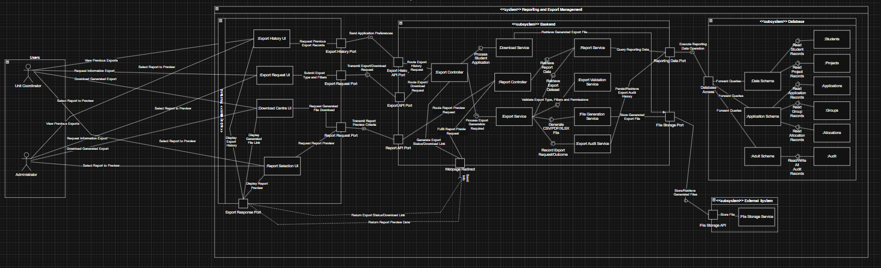
Figure 9.3.4.1 “Reporting and Export Management Component Diagram”
There are several key interfaces defined within the Reporting and Export Management Component, distributed across the frontend, backend, and database layers. These interfaces facilitate communication between subcomponents to generate files to users.
The Export History Port is used by the Export History UI to retrieve a log of previous export requests from the Export Controller, allowing users to see past exports.
The Export Request Port is used by the Export Request UI to communicate with the Export API, allowing UCs and Admins to request exports according to the submitted types and filters.
The Report Request Port is used by the Download Centre UI and the Report Selection UI to communicate with the Report API, allowing UCs and Admins to request a report preview and a download for the generated file.
The Export History API is provided by the Export Controller and is consumed by the Export History UI via the Export History Port. This API is used to route export history requests.
The Export API is provided by the Export Controller and is consumed by the Export Request UI via the Export Request Port. This API is used to route export/download requests.
The Report API is provided by the Report Controller and is consumed by the download Centre UI and the Report Selection UI via the Report Request Port. It handles preview requests and file download requests.
The Reporting Data Port is provided by the database layer and acts as the primary interface for the backend to acces the database so that the component can generate a file requested by users.
The File Storage Port is used as access to store and retrieve files generated by the Export Service.

9.3.5 Functional Services
- Export History - Allows users to see their history of export requests.
- Export Request - Allows users to request an export with constraints.
- Report Preview - Allowes users to preview the requested report before downloading the report.
- File Download - Provides a download for users.

9.4 Theory of Operations
Before an export is generated, the users must use the Export Request UI to specify what data they want to export, what filters to apply, and what file type. This request is sent to the Export Controller, which first passes through the Export Validation Service to validate the request.
Once validated, the Export Controller passes the request to the Export service, which queries the relevant database schemas through the Reporting Data Port. The retrieved dataset is then passed to the File Generation Service, which generates the requested file and stores it to the File Storage Service.
After the file is generated and stored, the file can be previewed before downloading the file. The file can be accessed through the Download Centre UI. This UI shows the preview of the generated file and the download link to download the generated file.
Users can then also view the Export History to see the list of Export Requests they have done and see what files are generated.
This covers the Functional Requirement of allowing UCs to export group allocations for a backup.

9.5 Security and Ethics
There is no security concern for this component, as the only users who can access this component have the highest level of access among all users. The only users who can access the component being the UCs and Admins.

10. Architectural Specification - Performance Monitoring, Error Handling and Debugging

10.1 Performance Monitoring
To keep the application working responsively, at scale and reliably with variable use, we will implement performance tracking for the system. Continuous metrics will be collected on key performance indicators (KPIs) such as response time, request processing rates, database query completion rates and system availability.
We will use Node.js's built-in logging and monitoring tools to collect data from our backend (API response times, and server load). The data from our database (Supabase) will include query execution time and how many connections are being used. We will also evaluate performance by collecting KPIs related to user experience via Vue.js (page load time, rendering speed, and delay between user interactions).
In addition to internal monitoring tools, we may integrate third-party monitoring solutions such as uptime monitors, dashboards that display a real-time view of the health of the entire system. If any of these KPIs exceed pre-configured threshold values (for example, if response times are too long, or requests fail), alerts will automatically notify development teams so they can identify and resolve performance issues before users notice them.

10.2 Debugging
Development Tools and Structured Coding Practices will be used for debugging of both Frontend and Backend components.
Node.js development tools including console logging, breakpoints and debugging environment (VS Code debugger) will be used on the backend to follow the path of execution and find problems. The developers can check the values of variables, observe API call activity and step through their code in order to determine where a bug is located.
The front end developers will utilize browser development tools (Chrome Developer Tools) to investigate UI issues, review network request information, and view the errors that are being thrown by JavaScript. Additionally, Vue.js has built-in debugging features available through Vue DevTools which allows developers to see what state a component is currently in, along with event tracking.
Additionally, development will be aided by using consistent coding practices that include a modular approach, meaningful names for all variables, and commenting of code. The error message generated will provide enough detail so that a developer may quickly determine why an issue occurred when developing or testing the application.

10.3 Error Logging
Logging of errors is going to be integrated into the software to record and analyze errors which occur within the systems so they can be maintained and improved upon. The system will generate logs based on different levels of the ERROR depending on how severe an issue was.
The system will utilize standard levels of logging such as:
- INFO - general system operations (example: successful request)
- WARN - potential issues which do not directly affect functionality
- ERROR- failure that causes specific system functions to fail (example: failed API call)
- DEBUG- detailed information used during development and troubleshooting
Backend logs will be created by utilizing logging libraries (examples: Winston or built-in console logging), whether logged locally or logged to a centralized log service. Supabase may also auto-log database related errors.
Errors that occur on the frontend side (such as, failed API request or UI issues) will be recorded with browser logs and sent to the backend for central management.
A structured approach to logging of errors allows problems to be quickly identified, tracked, and corrected; providing better reliability and maintainability of systems.

